Practical: 7 | Implementation of making a change problem using dynamic programming
15/09/2026

Aim: To implement of making a change problem using dynamic programming

Algorithm:

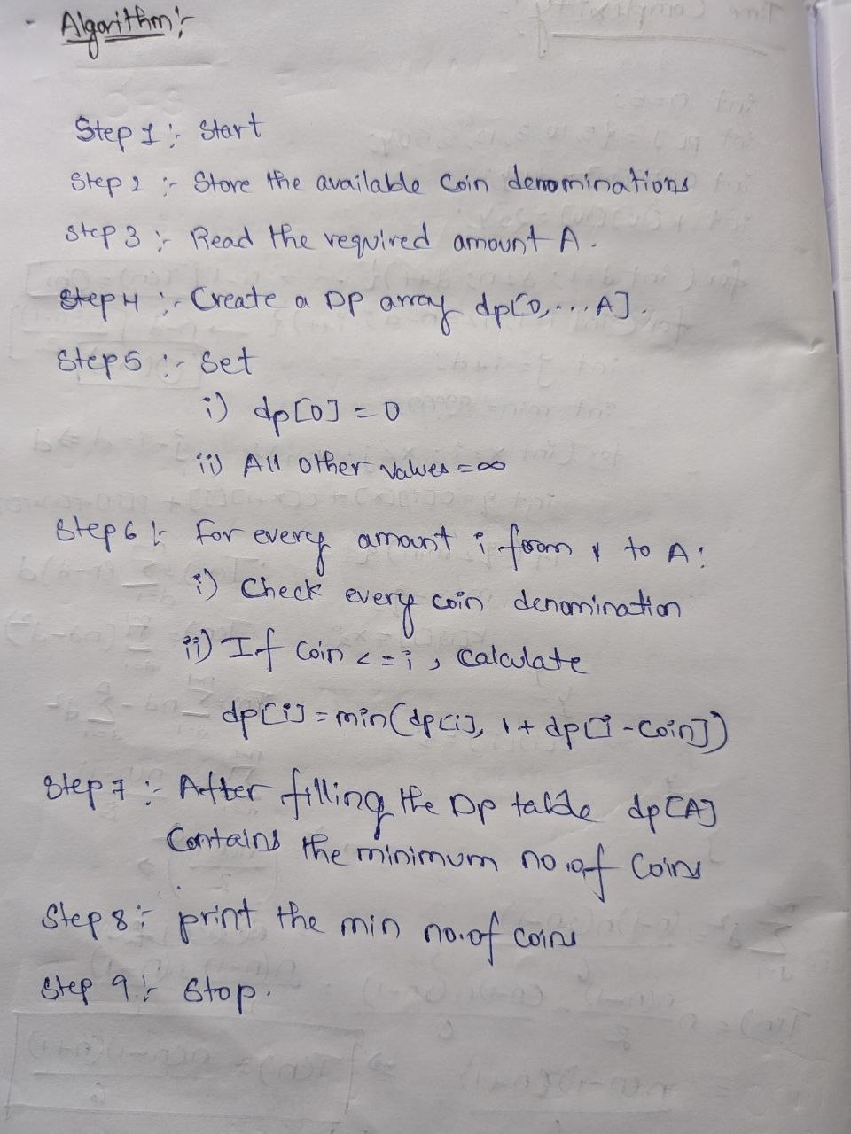

Program:

#include <iostream>
#include <algorithm>
using namespace std;

int main()
{
// Static coin denominations
int coins[] = {1, 2, 5, 10};

int n = 4;
int amount = 12;

int dp[100];

// Base case
dp[0] = 0;

// Initialize DP array
for (int i = 1; i <= amount; i++)
dp[i] = 9999;

// Dynamic Programming
for (int i = 1; i <= amount; i++)
{
for (int j = 0; j < n; j++)
{
if (coins[j] <= i)
{
dp[i] = min(dp[i],
1 + dp[i - coins[j]]);
}
}
}

cout << "Coins: 1 2 5 10" << endl;
cout << "Amount: " << amount << endl;

cout << "Minimum number of coins = "
<< dp[amount] << endl;

return 0;
}

Output:

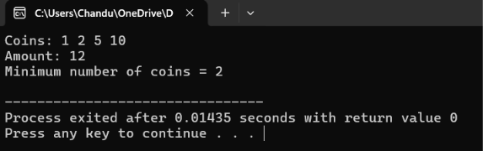

Time Complexity:

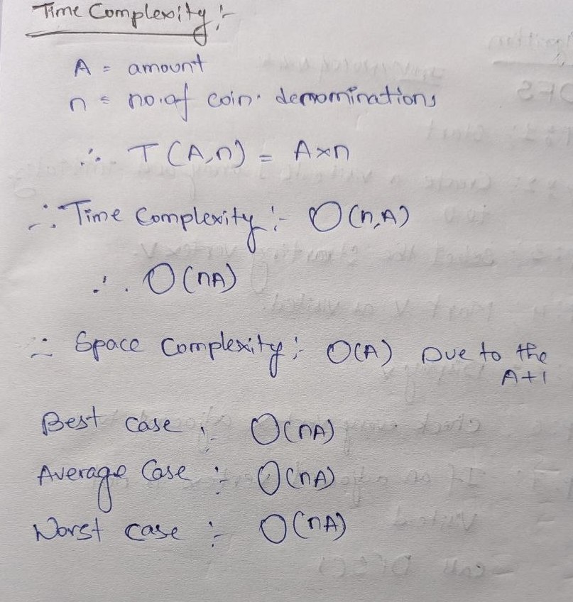

Conclusion:
The Implementation of making a change problem using dynamic programming is successfully executed with the time complexity of O(nA) along with same for all the three cases.
Best case = Average case = Worst case = O(nA).

